HOW TO ACCESS THE RESOURCE LIBRARY - BENETRAC
Step 1: Go to Benefits Administration in the Menu.
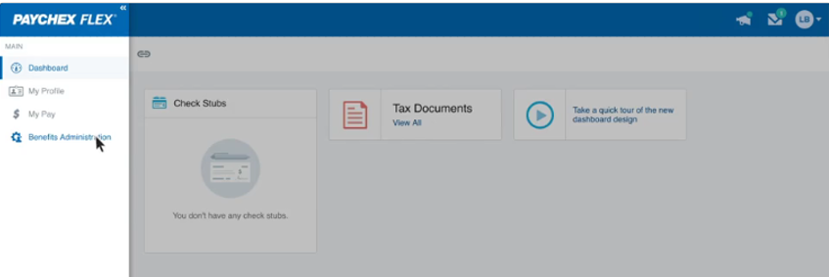
Step 2: Read the legal notice, then click I AGREE.
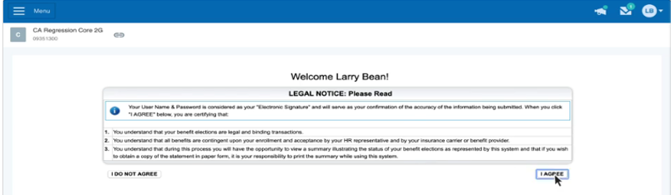

Step 3: Click on Resource Library
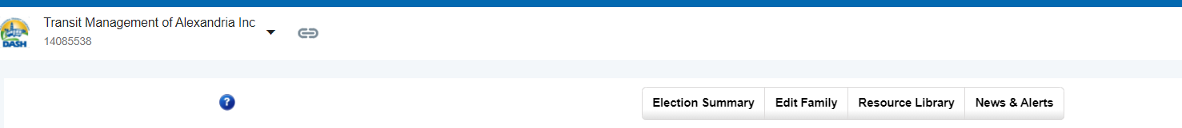

Note: The Resource Library will open in a new window. See below.

