**How to Enroll in benefits during Open Enrollment through Paychex Benefit Administration**

**You must be logged on to your Paychex profile before proceeding. To log on click** [**here**](https://myapps.paychex.com/)**.**

Step 1: Go to Benefits Administration in the **Menu**.

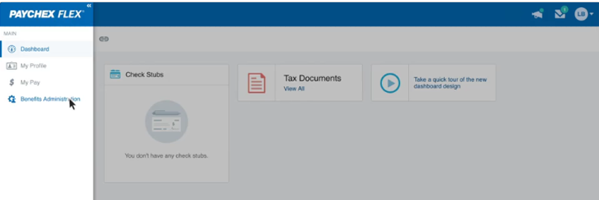

1. Read the legal notice, then click **I AGREE**.

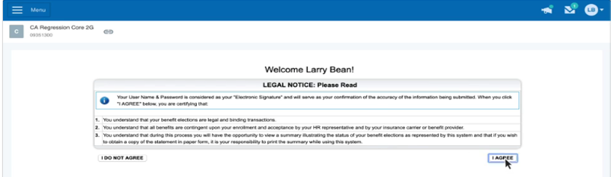

1. Click **ADD a family member to** add any family member you wish to enroll. This must be done **prior** to starting your open enrollment changes.

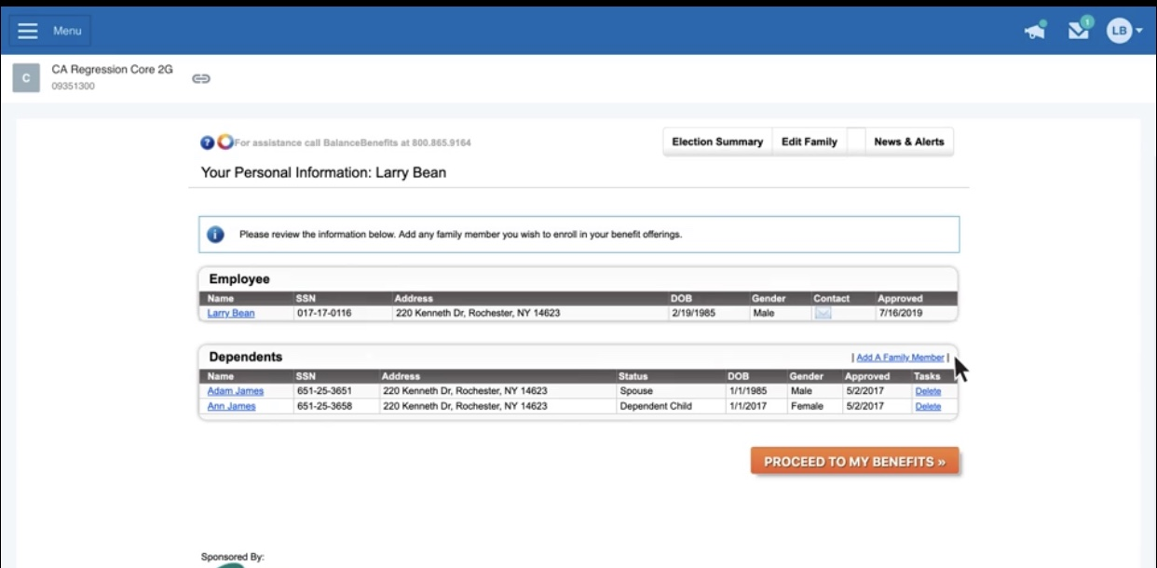

1. Click **PROCEED TO MY BENEFITS**. Welcome to the benefit dashboard. Here you can find the record of your benefits and your dependents.

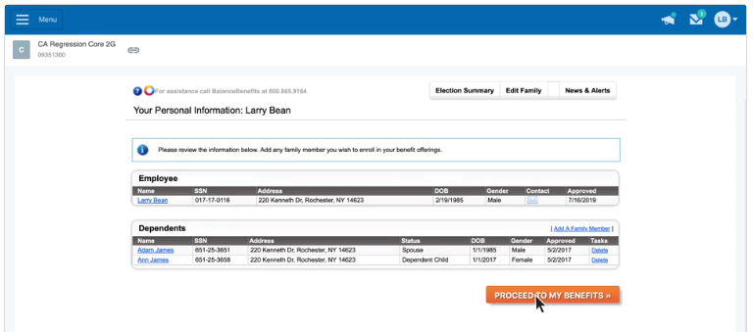

1. To enroll, click **MANAGE BENEFIT** next to a benefit. Then select **Add or View Plan/Options**.   
   Want to review a benefit you’re already enrolled in? Select **Change or View Plan/Options**.

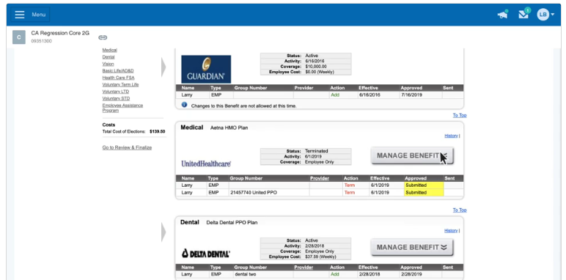

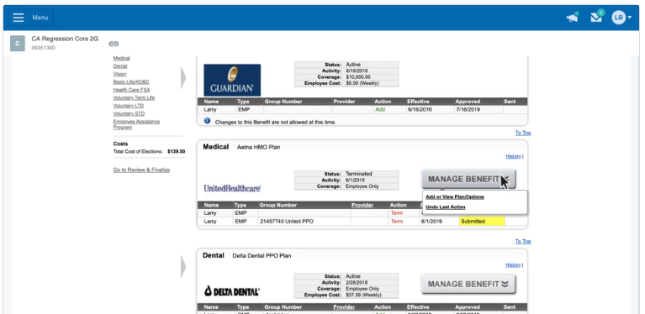

1. Select all the dependents you would like to include, then click CONTINUE

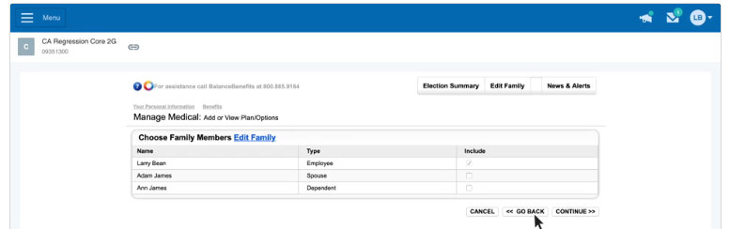

1. Select the plan you want to enroll in, then click CONTINUE.

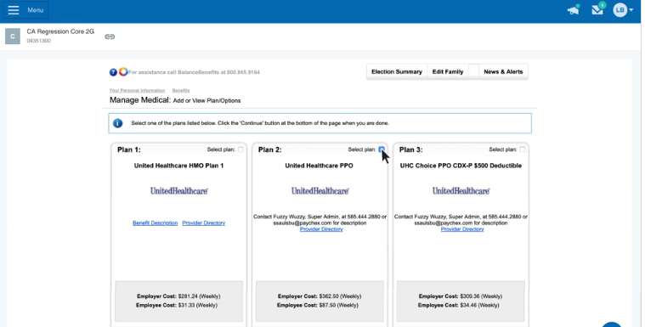

1. Read the message, confirm that the information is correct, then click I AGREE.

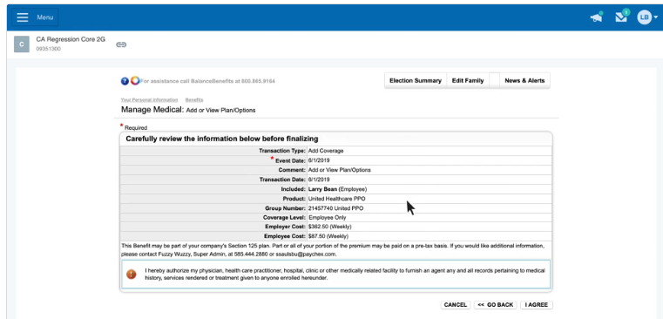

1. A confirmation screen will verify your decision. Click **OK** to return to Benefit Administration.

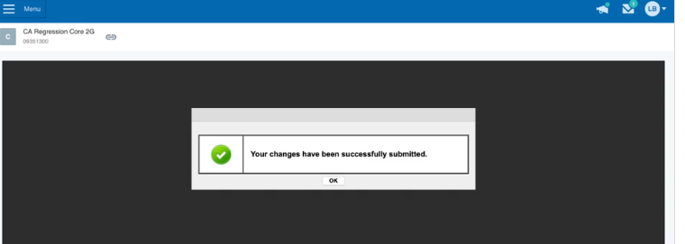

1. After you have reviewed all your benefits Click **REVIEW & FINALIZE**. **When you are done with your changes or review of benefits, you must finalize your elections.**

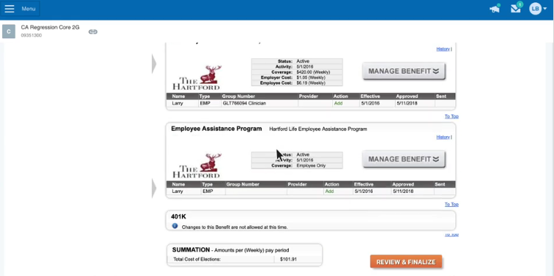

1. Review the elections Summary.

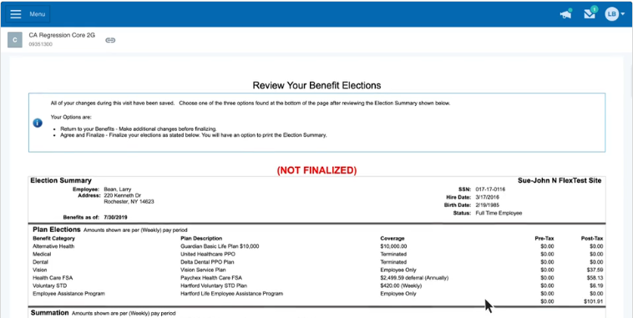

1. Still want to make changes? Click **RETURN TO MY BENEFITS** and update your selections.

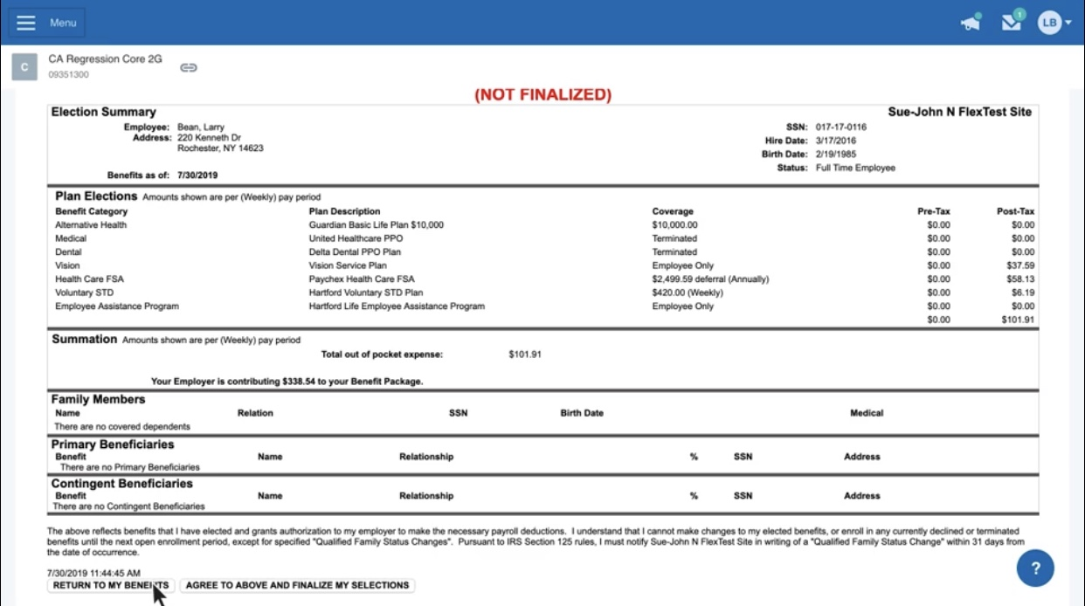

1. After you have made all your changes, read the message, then click **AGREE TO ABOVE AND FINALIZE MY SELECTIONS**.

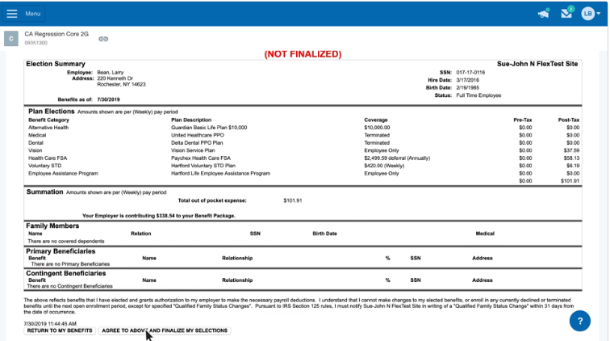

1. You then have the option to print your benefit elections summary.

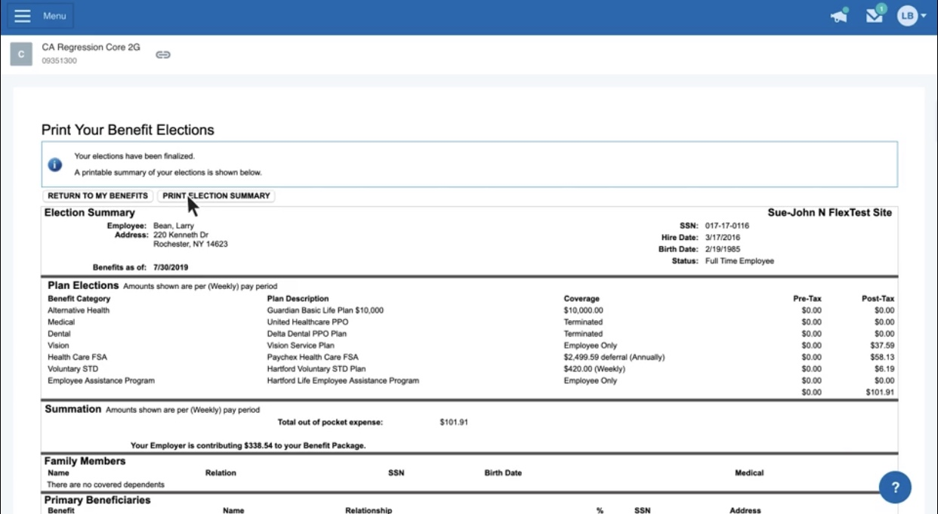

**To Waive or Decline a benefit:**

Want to decline a benefit you are currently enrolled in?

* Click **Manage Benefit** and select **Decline Benefit**.

Pro tip: The system will automatically decline any benefits you don't enroll in.

**Help Center:**

A video on How to Enroll in Benefits during Open Enrollment can also be accessed through the help center

Please see instructions below

1. Click Help Center [1], then enter ENROLL IN BENEFITS DURING OPEN ENROLLMENT in the search bar [2]. Hit ENTER [3]. Select the ENROLL IN BENEFITS DURING OPEN ENROLLMENT article to view video.

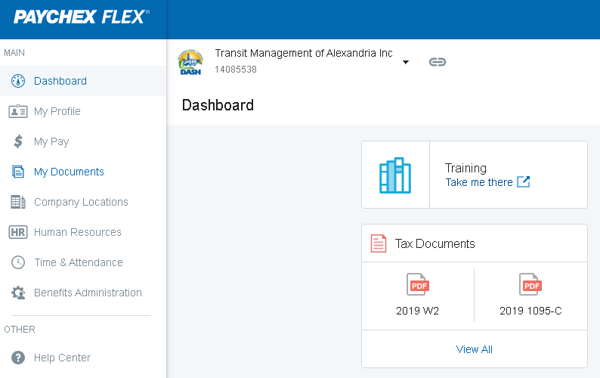

**1**

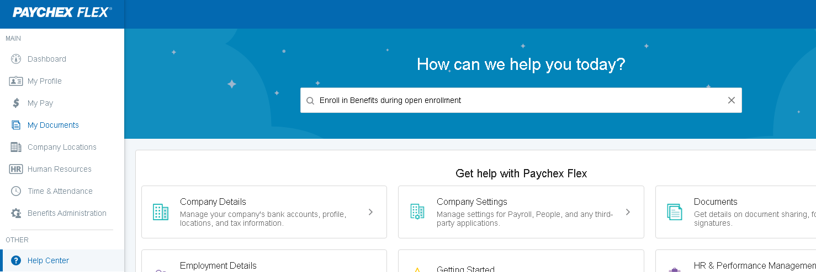

**2**

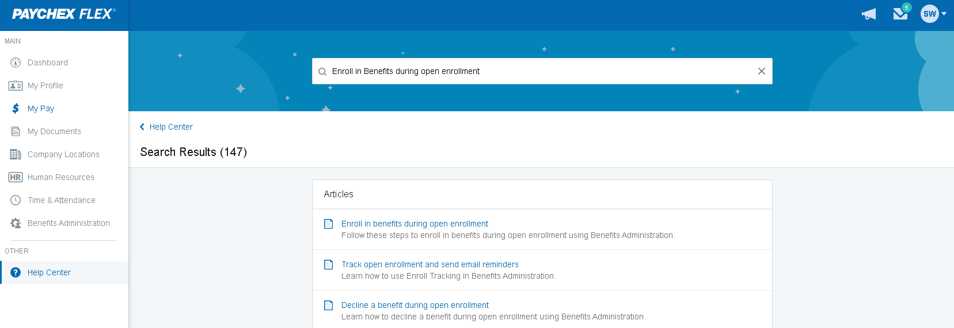

**3**

